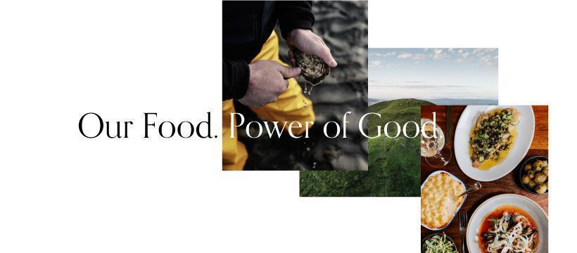
Taste of Ulster Application Form
Our job, and our passion, is to promote Northern Ireland food and drink both locally and worldwide. We tell media and food writers about our members, we organise events and we are relentless in our pursuit of positive publicity.
As a member, you will be invited to take part in various opportunities to promote your establishment or company, your chefs and your excellent food.
One of our most recognised initiatives is the imaginative and extensive marketing campaign – ‘Our Food. Power of Good’, to increase awareness among local people of the premium quality, nutritional value and safety of food and drink being produced in Northern Ireland. The key message is to support local through the strapline Source it, Savour it and Support it at www.nigoodfood.com.
The link to the Advert can be found at - https://youtu.be/HojeDpYqkFk
Or, search in Google for ‘Taste of Ulster TV Our Food. Power of Good’
We look forward to working with you in 2026, as we continue to enhance the reputation of food and drink from Northern Ireland. Simply fill in this form and return with your payment to us as soon as you can, to avail of these opportunities. The purpose of this form is so we have all your up to date contact details for the year ahead.

Name of Establishment

Contact Name and Position

Business Address

Telephone Number

Mobile Number (for admin only)

Email Address (for the Guide)

Email Address (for admin only)

Name of Head Chef (for chef steering group and cookery demo)
Telephone Number/Email Address

Name of person who deals with accounts:

Telephone Number/Email:

Marketing Contact Name &

Telephone Number/Email

Web Address: _______________________________________________

Your Twitter Name: _______________________________________________
Please “follow” @Food_NI

Your Facebook Name: ______________________________________________ _
Please “like” FoodNI

Your Instagram Name: _______________________________________________
Please “follow” @Food_NI

Please inform us of any changes including email addresses, as this is our preferred method of contact. Failure to do so may mean that important information and opportunities will not get to you.
Contact: alana@nigoodfood.com OR (028) 90 249 449
Please list local producers that you use in your establishment for the following, for us to cross-reference:
1. Beef and Lamb (or red meat):

2.Pork Products: inc. bacon and sausages:

3.Seafood and shellfish:

4. Vegetables:

5. Dairy produce inc. milk, cream, butter, eggs, ice cream:
6. Bread (or let us know if you make your own):

7. Miscellaneous (preserves, spreads, seasonings, drinks…):

Current FSA Food Hygiene- Rating ________________ Date Issued__________________
*Please note to become a member you must have a Food Hygiene Rating of 3* or above*
How often do you change your menus? __________________________________________
Taste of Ulster Membership Fees: The amount depends on the seating capacity of your establishment, please tick which applies to you.
No of Covers | Price to pay exc. VAT | Please tick or highlight
Up to 29 Covers | £275.00
30-59 Covers | £325.00
60+ Covers | £375.00

Please note: Groups of 2 or more establishments can avail of 10%, Groups of 3 or more establishments can avail of 20% discount and Groups of 6 or more can avail of 25% discount.
Please contact our office for more information.

Membership Fee MUST be paid within 30 days of your invoice
Payment Details Please write all cheques payable to Food NI Limited and post to Belfast Mills, 71-75 Percy Street, Belfast, BT13 2HW.
BACS Details Ulster Bank, Coleraine
Sort Code 98-04-40
Account Number 10222454
Please ensure you email BACS remittance of electronic payments to info@nigoodfood.com
When making payment please reference your invoice number as your payment reference.

Signature Date

Thank you for completing this application form. By returning this form with your payment to Food NI, you and your establishment agree to the following:
- Receive email updates and newsletter from Taste of Ulster/Food NI.
- You will uphold the Taste of Ulster Charter.
- You will source, use and promote local food, where possible.
- The information given is truthful and is allowed to be used in the Taste of Ulster Guide and on our website, once you have passed your inspection.
- You will cover the payment for the inspector’s 3 course meal and 1 local drink (this can be alcoholic if on licenced premises, providing you are inspected on a Tuesday, Wednesday, Thursday or Friday.
- The membership fee will be paid within 30 days of your invoice.
- The membership fee and/or the value of the food voucher will not be reimbursed.
- You agree to your contact details being passed onto third parties for the purpose of marketing your business.

Please return this form to one of the following: alana@nigoodfood.com / info@nigoodfood.com

