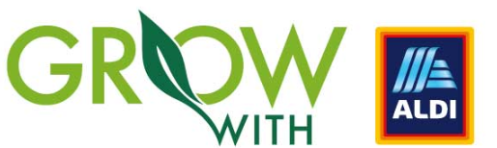
PLEASE SEND COMPLETED VERSION TO GROW@ALDI.IE
Applicant Name
Applicant email address
Applicant contact number
Business name
Number of employees
How many units of products can you produce per month
Does your product or company have any sustainable features eg. Sustainable packaging, low carbon footprint, organic etc.
Address of Production Facility
Level of food industry accreditation at production facility
Tell us about your company and your products
Number of products entering and names (up to 5)
Have you taken part in the Grow with Aldi programme before?
Is your product ready for market (shelf ready)?
Is your product produced in Ireland?
Is your business a member of Origin Green?
Does it have a 13 digit barcode?
What is your recommended retail price?
Is your product Ambient/Chiller/Freezer?
Approx. shelf life
Please attach a product image

