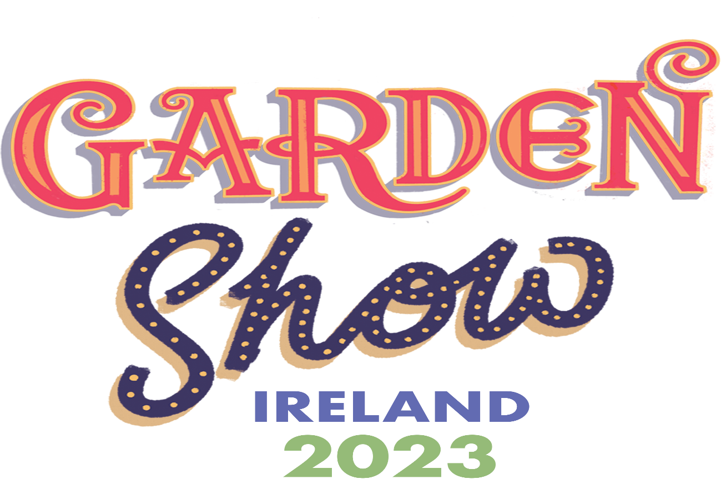

Friday 16th June to Sunday 18th June
2023
Antrim Castle Gardens

Food Pavilion Application form.
We would like to offer you the opportunity to apply to take a pitch as a food or drink producer, to sell your products at the event this year. There is also the opportunity to sell food to go at the event, including tea and coffee offerings and dessert offerings.
Food stall holders should be producers of local produce. As we anticipate a high volume of applications, please provide as much evidence of using local ingredients in your products as possible.

Company Name -
Contact name -
Position in the company -
Telephone number -
Email address -
Website -
Please provide some information on the products you plan to sell at the event:
____________________________________________________________________________________________________________________________________________________________________________________________________________________________________________________________________________________________________________
Please return this completed form to Christine christine@nigoodfood.com by Friday 31st March 2023. Booking forms will be sent out in February. If you have any queries about this please call me on 07735209299.
Participation fees are as follows –
Producer pitch fees – Food NI member rate - £275 plus VAT
Non member rate - £315 plus VAT
Food to go – Member rates - £575 plus VAT
Non member rates - £625 plus VAT
Tea/Coffee/Ice cream rates – Member rates -£415 plus VAT
Non member - £465 plus VAT.
There will be a fee for electricity (cost tbc closer to the event) Please indicate if you need electricity and your requirements - ___________________________________________
The above fee includes space in a marquee for producers. It does not provide cover for food to go. As stands are limited we may have to select attendees from each food category to ensure a diverse coverage of produce. You will be informed if your application has been successful by 14th April 2023 .
Please note that we are aiming to have a plastic free site, food to go providers are asked to use recyclable/ biodegradable cutlery etc. For food and drink producers, sample pots should be paper and not plastic.
We also require insurance details and a risk assessment at this stage. For food to go vendors could you please provide an image of your set up/ food trailer along with this application form. Applications will not be considered without these documents.
