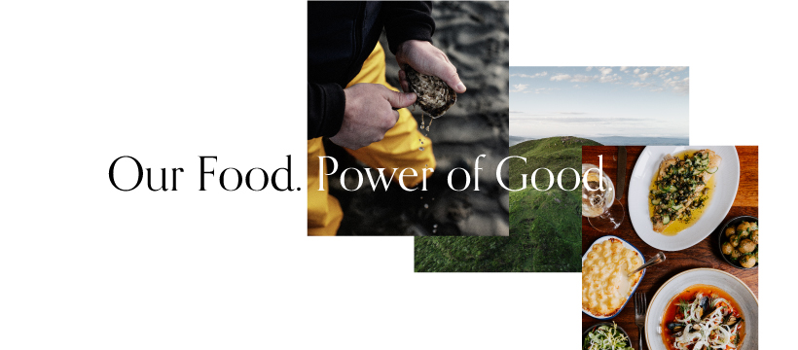
2022 FOOD NI MEMBERSHIP FORM
Our job, and our passion, is to promote Northern Ireland food and drink both locally and worldwide. We tell media and food writers about our members, we organise events and we are relentless in our pursuit of positive publicity.
We have just launched an imaginative and extensive marketing campaign – ‘Our Food. Power of Good’, to increase awareness among local people of the premium quality, nutritional value and safety of food and drink being produced in Northern Ireland. The key message is to support local through the strapline Source it, Savour it and Support it at www.nigoodfood.com.
The link to the Advert can be found at - https://youtu.be/HojeDpYqkFk
Or, search in Google for ‘Taste of Ulster TV Our Food. Power of Good’
We look forward to working with you in 2021/2022, as we continue to enhance the reputation of food and drink from Northern Ireland. Simply fill in this form and return with your payment to avail of these opportunities. Cost of membership is based on annual company turnover.
Company Name

Main Contact Name

Postal Address

Main Contact No.

Main Contact Email

Finance Contact Name

Finance Contact Email
Sales/Marketing Contact Name
Sales/Marketing Contact Email
Website
*Please regularly check www.nigoodfood.com and remember to send us news and information relevant to your product(s)/company so we can promote you business, e.g. new product launches, new customers secured, awards.
Nature of your business, e.g. type of food(s) produced/processed/your suppliers (if appropriate):

Please list 3 local ingredients/suppliers that you use (if relevant):
1.
2.
3.
Retail
Do you currently supply your product(s) to retail outlets? YES NO
If yes, which retail outlets?

If no, which retailers are you interested in supplying?
___________________________________________________________________________
Hospitality
Do you currently supply any restaurants? YES NO
If yes, which restaurants?

If no, which hospitality outlets are you interested in supplying?
___________________________________________________________________________
Is your facility suitable for pre-arranged visits from media / food journalists? YES NO
If no, are you interested in supplying restaurants Is your facility suitable for pre-arranged visits from the general public? YES NO
Do you have any annual open days?

Please write your Twitter,Facebook and Instagram Account Names here so we can follow you. Please follow @Food_NI

By signing this form below, you agree to become a member of Food NI if approved, for the duration agreed, and noted on your invoice. You are agreeing that your product(s) are grown, reared, produced or processed in Northern Ireland where possible. You agree to pay your membership fee within 30 days from the date of invoicing. As a fully paid up member of Food NI, you will be permitted to use the Food NI logos. These are available on request.
By signing and returning this form, you agree to Food NI retaining your contact details in accordance with the provisions of the GDPR. You understand, and agree that your contact details will be available to the public on www.nigoodfood.com.

Signed

Position in Company

Date

New Members: We will send you an invoice on return of this form. Thank you.
Existing Members: We will send you an invoice on the month that your membership is due. Thank you.
Please make cheques payable to Food NI Ltd.
BACS details: Ulster Bank Sort Code 98-04-40 Account No: 10222454
When making payment, please add the invoice number as your payment reference.

