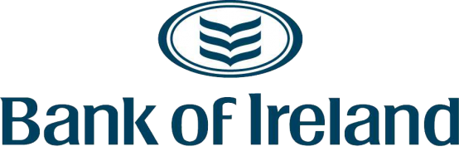

We’re mindful that many businesses and households are struggling and that circumstances are changing fast and some of you have asked where to find information. Here’s an overview of just some of the support
Government:
The announcement on the Gov.uk website lists the various measures available and who is administering them https://www.gov.uk/government/publications/guidance-to-employers-and-businesses-about-covid-19/covid-19-support-for-businesses – it is comprehensive & updated as they add additional measures. In NI, the rates holiday will be for 3 months and apply to all businesses, and rates bills will be deferred from April to June to help with short-term cashflow. The grants and business rate relief scheme is devolved to the NI Executive and the package they have announced will be administered by InvestNI. Details can be found here: https://www.economy-ni.gov.uk/news/covid-19-business-support-grant-schemes.
The ‘business interruption’ loan scheme (up to £5m loans) will launch next week and will be delivered through the British Business Bank and the BBB link is: https://www.british-business-bank.co.uk/ourpartners/coronavirus-business-interruption-loan-scheme-cbils/
Two schemes involving the Bank of England:
- The measures on 11th March included a term funding scheme aimed at SMEs delivered via the banks: https://www.bankofengland.co.uk/news/2020/march/boe-measures-to-respond-to-the-economic-shock-from-covid-19. Ask your bank about support.
- Another scheme for larger firms via the Bank of England https://www.bankofengland.co.uk/news/2020/march/hmt-and-boe-launch-a-covid-corporate-financing-facility and for which there is a market notice explaining some of the detail of how the facility will work: https://www.bankofengland.co.uk/markets/market-notices/2020/ccff-market-notice-march-2020. Application forms and pricing will be added to the Bank of England’s website on Monday 23rd. The Bank will publish a dedicated webpage for corporates seeking to use the CCFF as soon as possible.
The Association of British Insurers have issued a statement on business insurance cover here and have a COVID-19 Q&A here which includes business insurance, trade credit, income protection and pensions and investments.
Also, in case useful:
- https://www.nibusinessinfo.co.uk/campaign/coronavirus-updates-support-your-business - Website operated by InvestNI
- FSB have a list of people to speak to for help https://www.fsb.org.uk/resources-page/what-help-for-coronavirus-covid-19-will-there-be-and-where-can-i-go-for-it.html
- For anyone involved with charities: https://www.civilsociety.co.uk/news/coronavirus-what-charities-need-to-know.html
- Consumer Council NI which may also be useful for employees https://www.consumercouncil.org.uk/coronavirus
Any additional feedback/updates that you can provide on what you are experiencing - on supply/demand/credit/whatever is relevant - please send them to NorthernIreland@bankofengland.gsi.gov.uk.

