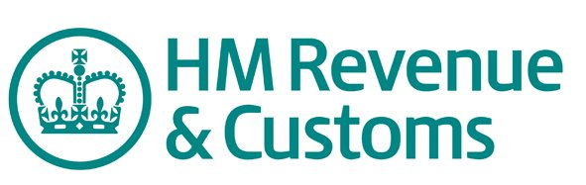

Advice on VAT/ PAYE and Corporation Tax

If your business is genuinely affected by COVID 19 we understand you can contact HMRC support and ask to defer VAT/ PAYE and Corporation Tax.

To find to more phone the HMRC COVID 19 Support line on 0800 0159 559.
HMRC are taking a sympathetic approach to businesses regarding VAT/tax bills so payments may be deferred for the next 3 months initially and will be constantly under review.
-Similar guidance is in place for PAYE and Corporation tax.
-They can add notes to your account to cover all 3 tax types (VAT, PAYE, Corp Tax).
-You need to contact them again closer to the end of the next VAT quarter to confirm payment delay plan and reasoning and to plan to submit VAT returns etc. as normal.
-You must contact HMRC to make them aware and you do need to contact your bank to suspend the Direct Debits for VAT, PAYE, Corp Tax.
CLICK HERE for a number of relevant publications.

