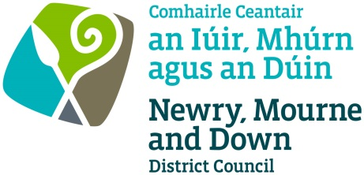
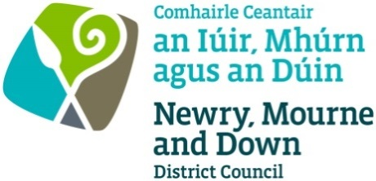
HALLOWEEN
TWILIGHT MARKET
1 NOVEMBER 2019

APPLICATION FORM

Newry Mourne and Down District Council will be hosting a Twilight Market as part of the Halloween events in Newry Market on Friday 1 November 2019 from 5pm – 10pm. This is a food, drink and craft event and is open to local food traders and producers, local drink producers and crafts. The cost of this event is £50.00 which includes your stall and electric.

Company Name
Contact Name
Address
Telephone Number

Mobile Number

Email Address

Brief description of proposed food/drink/craft offering:

Electricity required | Yes / No
Brief description of the type of electrical equipment you will be using;*
Please advise what type of plug you are using and how many
Please state what ampage you require and if it is domestic/blue/3phase
Please advise which Local Authority your food business is registered with.
Food Hygiene rating scheme score if applicable which must be displayed on the night with allergy information.
(A copy of your Statutory Food Hygiene Rating Scheme - Formal Notification letter is required for file Please scan and email with this application)
Do you handle open food (out of packing)
If Yes how are you providing suitable provisions for washing hands and utensils including hot & cold or
appropriately mixed water supply and do you need electricity for this ?
Will you be using a Gas Appliance  (please attach copy of current gas safety certificate) | Yes / No - Fixed / Moveable
Please confirm that you have public liability insurance to the value of £5 million  ( A copy of this is required for file please attach) | Yes / No

All electrical items much be PAT tested.

*Mark clearly how much electricity you will require. Please note no electric will be arranged on the day and non-essential electricity cannot be guaranteed. All electrical items much be PAT tested.

Completed application forms must be returned to Tracey Mooney, Newry, Mourne and Down District Council at Bagenal’s Castle, Abbey Way, Newry by FRIDAY 18 OCTOBER at 12 noon.

Traders must be set up and ready to trade by 4.30pm. The Halloween Twilight Market will be closed at 10.00pm, takedown is to take place after the event. The Twilight Market is organised by Newry, Mourne and Down Council as part the City of Merchants Event

Signature: ________________________________________ Date: ________________________

Payment Details: Please make payment via credit/debit card Bagenal’s Castle or phone on 028 30 31 3170. All application forms need to be received by FRIDAY 18 OCTOBER at 12 noon.

If you have any further queries email tracey.mooney@nmandd.org

Please note no refunds will be given on cancellations or inclement weather.

