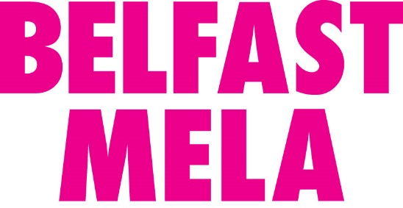

Thank you for expressing interest to trade at the Belfast Mela 2019 which will take place on the 25th August 2019 from 12noon-6pm at Botanic Gardens. Please read and fill in the form below as soon as possible. The application process will remain open until the 31st May 2019.
Please note an application does not automatically secure a space at the event and you will be informed of your place, if successful, by the end of June at the very latest.

PART 1: COMPANY DETAILS
Company Name

Contact Name

Address

Contact Mobile Number

Email Address

Have you traded at Mela before?
YES
NO

What type of business are you?
Restaurant
Mobile food business
Market trader
Other (please specify)

PART 2: QUALITY ASSURANCE
Can you provide a brief description of your product?

Can you detail your trading experience at large events with audiences of 20,000 over one day?

Can you provide us with evidence that your product is of high quality and sourced locally in Northern Ireland?

Are you part of the Food Hygiene Rating Scheme in Northern Ireland. If so, what is your star rating?

If applicable, are you and your staff trained in the use of the Hazard Analysis Critical Control Point food management system?

PART 3: CATERING STALL CATEGORIES
Please choose which stall category you wish to book. If you are unsure what category to choose please contact us and we will advise.
Stall Category | Price | Tick
World Food Market  The festival's main catering area. We provide you a marquee, tables and chairs. In this marquee there is a communal food preparation area. Limited spaces available.  (Move to Part 5) | £450+VAT
Artisan Pavillon  The festival’s artisan pavilion. This is only available for small food producers selling dry food / jar products. Please ask if you are unsure if you all in this category. Space is limited.  (Move to Part 5) | £80+VAT | X
Standalone Units  Select this category if you have your own free standing structure e.g. a gazebo or self contained catering unit and just wish to rent ground space. The price will depend on the size of the space you wish to rent and will be quoted to you by email. Please complete the next section so we can provide you with a quotation. This category is more cost effective for small businesses with their own set up.  (Move to Part 4) | Price on request

PART 4: STRUCTURAL INFORMATION
Please complete if you have ticked the 'standalone unit' category in the previous section. If not, move onto the next section.

Please indicate the type of structure you will be trading from?
Market stall
Converted vehicle
Marquee / gazebo
Purpose built
Other (please specify)
Please indicate the size of you structure in metres?
Length (including tow bar and all hatches)

Depth (including serving hatch)

Height

PART 5: POWER SOURCES
Do you require electric?
YES
NO

If YES, please indicate the category of power you require. If you are unsure of how much electric you require please consult with a member of our events team on what equipment you will be bringing.

16a single phase
32a single phase
16a three phase
32a three phase
63a single phase

Please indicate how much power (in watts) your equipment will draw?

If you require more than two 13a plug sockets as standard, please indicate how many?

Will you be using LPG appliances?
YES
NO

If YES, please indicate what type of gas equipment you will be bringing. All gas equipment must be certified by a Gas Safe Engineer and under no circumstances are any gas canisters allowed inside marquees.
We do not supply any catering equipment. Traders must bring their own industry standard catering equipment including refrigeration and cooking facilities where appropriate. We can recommend approved suppliers if you wish.

PART 5: CERTIFICATES & ENCLOSURES
Please enclose the following documents with your application. If these documents aren’t included the application will be considered ineligible.
Public, Product & Employers Liability Insurance

Market trade federation membership (if applicable)

Food hygiene certificate (Level 2 or above)

Gas safety certificate (if applicable)

PART 6: SUBMISSION
Please submit completed applications by post or email by the 31st May 2019 by using the details below:
POST: Glendinning House, 6 Murray Street, Belfast, BT1 6DN
EMAIL: admin@artsekta.org.uk

OFFICE USE ONLY
Approved
Declined
Follow Up
Quote

