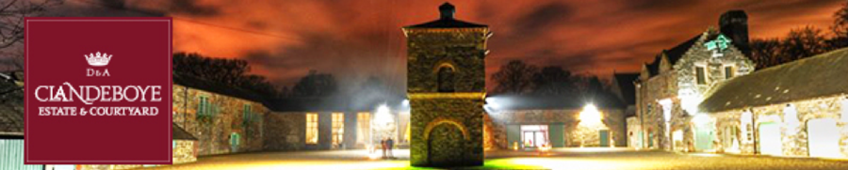
Clandeboye Foodie Festival
31st August to 1st September 2019
Set in the grounds of the stunning Clandeboye Estate, we are delighted to be able to offer this opportunity for local food and drink companies to showcase and sell their products at this event.

Application Form
Business name: _____________________________
Contact Person: _____________________________
Mobile Number: _____________________________
Email contact: ______________________________

The costs are as follows;
- Food and drink producers – one day cost - £ 50 , two days costs - £80
- Food to go – one day costs - £ 100 , two days costs £150

The hours are as follows –
- Saturday 31st – 11am to 6pm
- Sunday 1st September – 11am to 5pm
- Stand fees will be non-refundable should you decide to withdraw from the event after 31st July 2019.

Do you require electricity?
Yes No
If YES please list all electrical appliances to be used on the stand and the required Wattage/Kw: As stated there may be an extra charge for this.
____________________________________________
Information to be sent with this application form: Applications will not be considered without this information, without exception.
1. Description of your product(s)
2. Insurance Policy Copy (£5m Public Liability, £10m Employers Liability, Product Liability – if relevant).
3. Risk assessment for the event.
4. Food hygiene rating and food hygiene certs for producers attending.
Notes:
• All traders must carry sufficient first aid cover to meet the risk applicable to their stand.
• All trade stands must be open and manned by a company employee familiar with the product for the duration of the event.
• Places on the stand will be allocated to ensure the best variety is offered and a good representation of products from NI are shown. Once the application/selection process has been completed we will ask for payment. Payment - Please make cheques payable to Clandeboye Estate – Bank details are available on request from (christine@nigoodfood.com). Payment will be required to hold your space. If this is not received within a week of being requested the space will be offered to another company. Please do not make cheques out to Food NI.

PLEASE SIGN HERE
Name: _________________________
Position: ________________________

I wish to apply for a trade space at Clandeboye Foodie Festival, 2019 & agree to adhere to the terms and conditions below.
The criteria that each company must meet and sign up to before being considered is outlined below:
1. Adherence to opening hours.
2. Traders must comply with all relevant food safety, health and safety regulations and fire regulations.
3. Traders must supply their own equipment.
4. Traders must produce, or add value to, everything they are selling.
5. A company employee familiar with all products must be on site throughout the event. This would preferably be the producer him/herself.
6. Electrical appliances to be used MUST be specified on the application form and cannot change without notification to the organisers, at least one week before the event. All electrical appliances need to be PAT tested, this is a legal requirement.
7. Places at the event will be allocated by the organisers in the overall best interests of the market. Please note that the organisers’ decision is final.
8. The organisers reserve the right to restrict the number of stallholders in any particular product category in order to ensure that a wide variety of food is on offer at the event. This is in the interest of all traders, and will ensure adequate trade for all; a wide variety of foods will also make the event more appealing to the public.
9. All exhibitors are asked to provide small samples of their product for the public to taste.
10. All decisions regarding participation in this event are entirely at the organisers’ discretion.
For any further enquiries please contact:
(Christine@nigoodfood.com) or alternatively ring 02890249449
Thank you.

