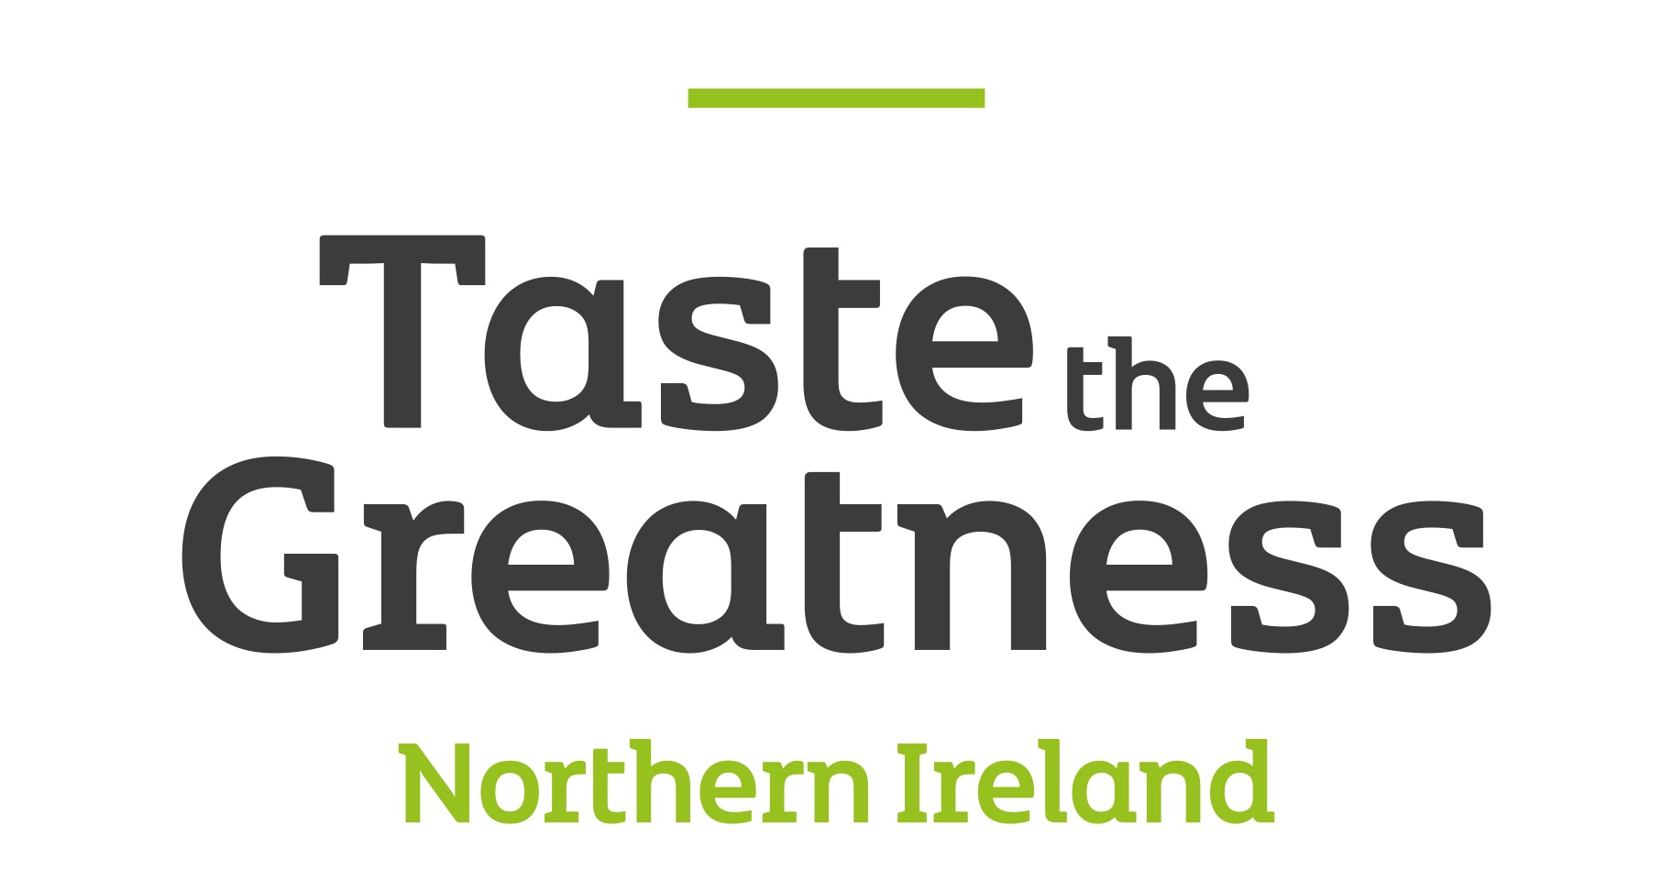

Application Form – Gifted, RDS
Dublin, RDS (The Royal Dublin Society), RDS Main Hall, Merrion Road, Ballsbridge, Dublin 4
4th – 8th December 2019

A fantastic opportunity for your company to attend an event with a dedicated Food Emporium.
Space available for quality Northern Ireland food and drink companies to sell with Food NI and Invest NI.
Due to the limited amount of space available, a selection process will take place.
Unfortunately, applicants may not sell food to go, ice-cream, hot tea or coffee. No food or drink can be sold for consumption onsite.

Business name:

Contact Person:

Mobile Number:

Email contact:

The costs are as follows;
- £200 (+VAT) per producer, for a shared 9mx 2m stand. This will give each company 1.5m frontage with the same at the back of the stand for storage. There is no extra storage available. This cost includes basic electric.
- Additional electrics may cost more.

The hours are as follows;
- Exhibition Arena Open 10.00am – 9pm for 4th, 5th and 6th December and 10am to 7pm for 7th and 8th December.
- Trading is from Wednesday 4th – Sunday 8th December.
- Stand fees will be non-refundable should you decide to withdraw from the event after 22rd November 2019.
- Space can only be booked for the whole show, not individual days.

Do you require electricity? Yes No

If YES please list all electrical appliances to be used on the stand and the required Wattage/Kw: As stated there may be an extra charge for this.

Information to be sent with this application form: Applications will not be considered without this information
1. Description of your product(s)
2. Insurance Policy Copy (£5m Public Liability, £10m Employers Liability, Product Liability – if relevant).
3. Risk assessment for the event.
4. Food hygiene rating and food hygiene certs for producers attending.

Notes:
As this is an Invest NI funded event, preference will be given to small/medium businesses who are clients of Invest NI.
• All traders must carry sufficient first aid cover to meet the risk applicable to their stand.
• All trade stands must be open and manned by a company employee familiar with the product for the duration of the event.
• Places on the stand will be allocated to ensure the best variety is offered and a good representation of products from NI are shown. Once the application/selection process has been completed we will ask for payment. Payment - Please make cheques payable to Food NI Ltd – Bank details are available on request from christine@nigoodfood.com) Payment will be required to hold your space. If this is not received within a week of being requested the space will be offered to another company.

PLEASE SIGN HERE

Name: Position:

I wish to apply for a trade space at Gifted, RDS 2019 & agree to adhere to the terms and conditions below.

The criteria that each company must meet and sign up to before being considered is outlined below:

1. Adherence to opening hours.

2. Traders must comply with all relevant food safety, health and safety regulations and fire regulations.

3. Traders must supply their own equipment.

4. Traders must produce, or add value to, everything they are selling.

5. A company employee familiar with all products must be on site throughout the event. This would preferably be the producer him/herself.

6. Electrical appliances to be used MUST be specified on the application form and cannot change without notification to the organisers, at least one week before the event. All electrical appliances need to be PAT tested, this is a legal requirement.

7. Places at the event will be allocated by the organisers in the overall best interests of the market. Please note that the organisers’ decision is final.

8. The organisers reserve the right to restrict the number of stallholders in any particular product category in order to ensure that a wide variety of food is on offer at the event. This is in the interest of all traders, and will ensure adequate trade for all; a wide variety of foods will also make the event more appealing to the public.

9. All exhibitors are asked to provide small samples of their product for the public to taste.

10. All decisions regarding participation in this event are entirely at the organisers’ discretion.

For any further enquiries please contact:
Christine@nigoodfood.com or alternatively ring 02890249449

Thank you.

