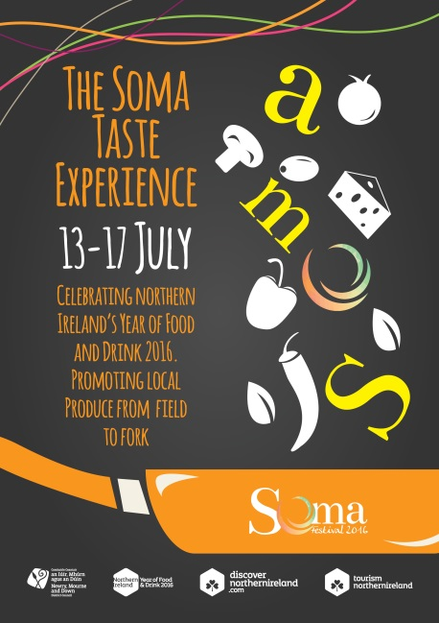
EXPRESSION OF INTEREST FORM
ABOUT:
Soma Festival has been running successfully since 2012 and focuses on live music events but in recent years we’re expanded to include a Children’s Programme, Workshops, Talks and a Body & Soul event.
This year’s event takes place 13-17thJuly with headline music events including Lisa Hannigan, Eddi Reader (Fairground Attraction) and Declan O Rourke with Donal Lunny and friends, Flook, Breaking Trad, Pipers' Union, Dublin Gospel Choir, Donal Scullion and the Spider Collective and many more.
To celebrate NI Year of Food & Drink 2016, we’ve got some new elements to this year’s 2016 Soma festival.
On the weekend of 16 -17th July we’re launching Soma Taste Experience; an artisan food and craft fayre with a focus on craft beers. We’ll have a tee pee and dedicated marquees for stall holders in the top square. We’ll be providing seating, live music and entertainment throughout the event to add to the unique atmosphere. We’ll be promoting the event and participating traders through local and national press, digital media platforms and our website www.somafestival.com.The festival coincides with the annual Castlewellan Show, located in the Castlewellan and will guarantee a footfall over the weekend of 10-15,000 people through the village.
We’re inviting local producers of innovative Northern Ireland products to get involved. Costs are £30 per day and £50 for both days. Please fill in the expression of interest form below and email info@macpr.co.uk .
EXPRESSION OF INTEREST
Name of applicant: __________________________________________
Name of business: __________________________________________
Description of business: _____________________________________
_________________________________________________________
_________________________________________________________
_________________________________________________________
Social media profiles- name:
Contact email: _____________________________________________
Contact mobile:____________________________________________
Do you have your own public liability insurance (copy required ): YES NO
Do you have your own mobile marquee/van or do you require marquee cover? YES NO
INTEREST IN WHICH DATES (tick both if applicable) 16th JULY 17th JULY

